**Ideation Phase**

**Define the Problem Statements**

|  |  |
| --- | --- |
| Date | 26 June 2025 |
| Team ID | LTVIP2025TMID59656 |
| Project Name | Enchanted Wings: Marvels of Butterfly Species |
| Maximum Marks | 2 Marks |

**Customer Problem Statement Template:**

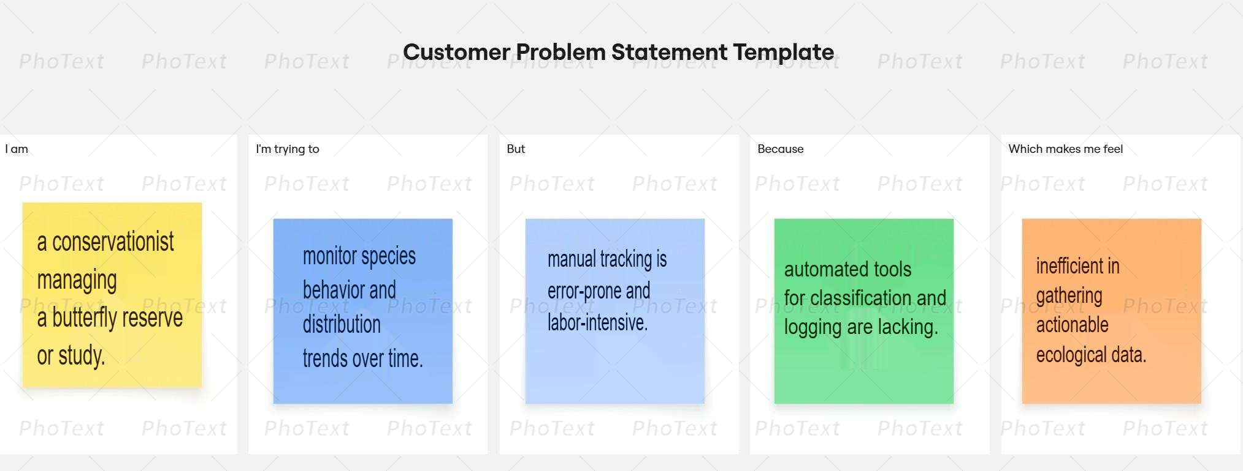To define the core problems users and sellers face in the online shopping ecosystem, and use those insights to guide the development of Enchanted Wings: Marvels of Butterfly Species

|  |  |  |  |  |  |
| --- | --- | --- | --- | --- | --- |
| **Problem Statement (PS)** | **I am (Customer)** | **I’m trying to** | **But** | **Because** | **Which makes me feel** |
| PS-1 | a field researcher working in biodiversity conservation. | quickly identify butterfly species in natural habitats. | manual identification is slow and requires expert knowledge. | real-time assistance isn't always available in remote areas. | limited in field data collection and delayed in analysis. |
| PS-2 | a student or enthusiast engaged in learning about butterflies. | recognize different butterfly species with confidence. | books and visual guides are limited and hard to use on the go. | they don’t provide instant feedback or learning support. | discouraged and uncertain while observing species. |